1. 
2. **Agenda**:
   1. We will write custom query using query method approach in Spring Data JPA.
   2. Then we will unit test it.
3. Let’s write Custom Query using Query Method Approach in Spring Data JPA.  
   The following EmployeeRepository.java class is in src/main   
   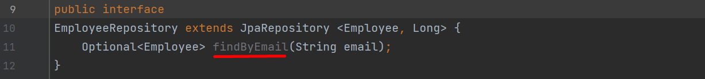
4. Writing the Unit Test for the above method.A screenshot of a computer

   Description automatically generated with low confidence  
     
   **Output**:  
   